//Q 1. Implement a Shape class with method area(), and override it in Circle, Rectangle

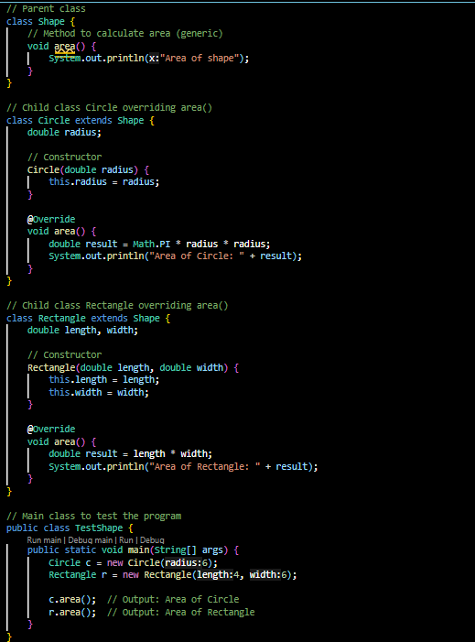

//output:

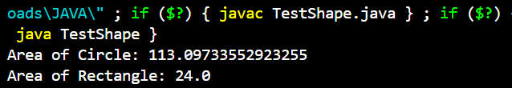

//Q 2. Create one parent class Vehicle, and two child classes Car and Bike.

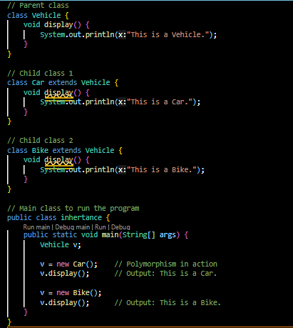

//output:

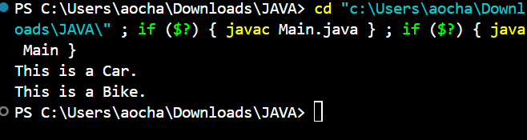

//Q 3. Create a class Employee with fields id, name, and salary. Write a method to display employee information. Create multiple employee objects and call the method.

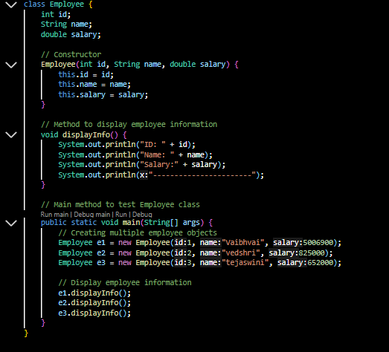

// output:

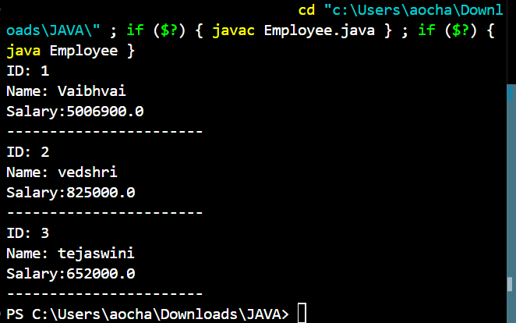

// Q 4. Write a program to create a class Calculator with methods to perform addition, subtraction, multiplication, and division. Create an object and perform all operations.

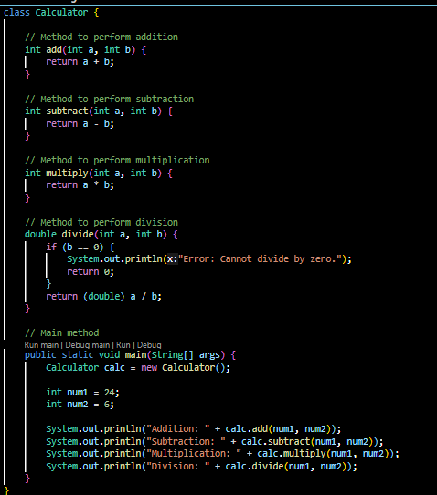

// output:

